Media Monitoring During Electoral Processes
Rasťo Kužel

Role of the media and importance of the media monitoring during elections
The media play a vital role in elections, as they inform voters about contestants and campaign developments, as well as about the election process. The media provide platforms for candidates to communicate their campaign messages to voters, analyze campaigns, communicate the views of various political groups, and report about those who hold power and seek to gain it again. The role and the functions of the media are limited if they do not enjoy free space to operate and to access information. The media should enjoy the freedom and no one should be allowed to restrain this because of their essential watchdog role. The media should adhere to the principles of fair coverage. A free and fair election process requires the media to treat all the contestants in a balanced manner and to strive to provide timely, correct and unbiased reports about all key political and election developments.
International human rights treaties, declarations and cases have created a number of standards by which we can measure the environment in which the media operate during elections. There are several fundamental principles which, if promoted and respected, enhance the right to seek, receive and impart information. During elections, media monitors provide benchmarks to judge the fairness of the election process. They assess the behavior of the media during various phases of the election process and evaluate their compliance with international standards and local regulations on election coverage.
They help to establish whether the candidates were given access to media to convey their messages to voters and whether information available through the media was adequate for voters to make a well-informed choice at the ballot box. Statistical data on the amount of time dedicated to contestants, the manner in which contestants and other key political actors are covered by the media, analyses of bias, extent and quality of voter education campaigns or relevancy of election-related information serve as basis for analyses. The results of the monitoring demonstrate how the media has behaved and keep the public and contestants aware of these issues. When shortcomings are identified, corrective action should be taken to improve media coverage or protect of media rights and freedoms.
During the elections, the broadcast media are key instruments influencing and shaping political, social and cultural realities and they have to comply with the ethical and professional standards of journalism. The nationwide media play a key role practically in all types of elections, as they serve as a primary source of information. Regional or local media could also

Media monitors in Georgia conduct quantitative analysis of television

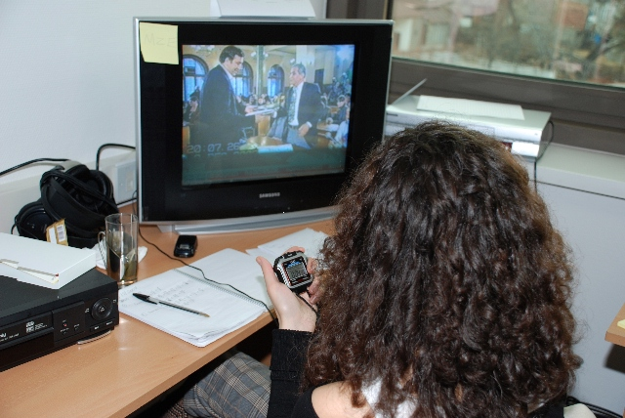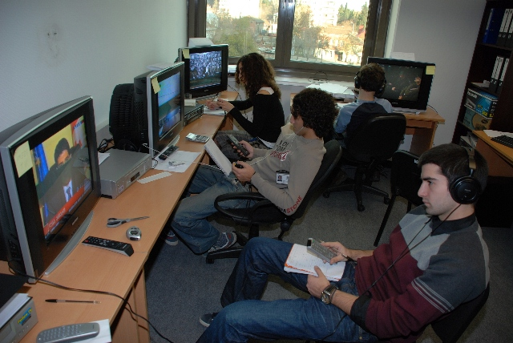

play an important role, both in parliamentary elections in the case of majoritarian election system or in local elections.
When assessing the variety and structure of the news, the following topics could be included:
- Domestic Politics,
- Economy
- Social issues
- Human Rights
- Energy issues
- International Affairs
- Relationship with other countries
- Health-care
- Culture
- Environment
- Civil Society
- Religion
- Minorities and Women
- Other

It can be said that the methodology provides for tools that allow monitors to address the following questions, among others:
- Is there balance and fairness in broadcasters’ coverage of election campaigns?
- Do broadcasters exercise balance in their coverage of contentious social issues?
- Is there gender balance in the voices quoted in news programmes?
Media monitoring by regulators
The regulatory system has a significant influence on the independence and professionalism of the media. A system with a strong control of a government is unlikely to promote pluralism and diversity among the media. A voluntary system (with strong legal or constitutional guarantees of media independence) can safeguard pluralism in the media and protect it against government or political interference and can help to develop professional skills and standards. Especially in transitional democracies, a clear regulatory framework is needed for media coverage of elections. Given the weakness of the democratic system which is not sufficiently developed, self-regulatory measures are seldom sufficient to ensure pluralism and fair access to all contestants.
Indeed, a system of self-regulation is more advisable when conditions facilitate responsible, mature journalistic coverage and a higher level of media literacy among the general public. For example in Georgia there is a system whereby the broadcasters are free to decide themselves how to react to violations of the Code of Conduct for Broadcasters by their staff (and these decisions may not be subject to legal or administrative sanctions). The Georgian media regulator (the Georgian National Communications Commission - GNCC) however is able to initiate its own investigation which can lead to the imposition of sanctions (ranging from a warning to the suspension or revocation of a license).
The most important aspect of any media regulations during elections is to find the right balance between respect for editorial independence and the need for certain rules to guarantee fairness by the media. During elections, it is important that the body which is in charge of overseeing the media coverage of elections is independent and trusted. This body should have experience, sufficient resources, knowledge, know-how, and mandate to oversee that rules are respected. It should act promptly upon contestants’ complaints or whenever it records a violation (regardless of whether it received a complaint) and properly investigate alleged violations. Consequently, it should impose effective remedies when violations take place. The Venice Commission’s Code of Good Practice in Electoral Matters in its chapter 3.6 (an effective system of appeal) states the following:
It is imperative that appeal proceedings be as brief as possible. Two pitfalls must be avoided: first, that appeal proceedings retard the electoral process, and second, that, due to their lack of suspensive effect, decisions on appeals – other than those concerning the voting in the elections and the results – are taken after the elections have been held. Finally, decisions on the results of elections must also not take too long, especially where the political climate is tense. This means both that the time limits for appeals must be very short and that the appeal body must make its ruling as quickly as possible. Time limits must, however, be long enough to make an appeal possible and for the commission to give its ruling. A time limit of three to five days (both for lodging appeals and making rulings) seems reasonable.
It should be clear which body deals with complaints from candidates and political parties about unfair or unlawful coverage. As stated above, these procedures should be timely, clear, and accessible to give the complainants a prompt and effective remedy. It is important that the sanctions imposed by the regulator are commensurate with the gravity of the offence committed by the media outlet.
As stated above, the key regulatory body for the broadcast media in Georgia is GNCC, which has responsibility for licensing and overseeing activities of the broadcast media. During the 2008 and 2010 elections, however, it was the Georgian Central Election Commission (CEC) which was in charge of monitoring the media.
The CEC conducted, for the first time, its own media monitoring, through the commercial company PRIME TIME, in 2008 (during the presidential election) and released three media monitoring reports before election day. While there was a clear media bias (identified in the monitoring of the OSCE/ODIHR election observation mission), the CEC’s interpretation of the monitoring results was positive, not identifying any substantial imbalances in the news. Similarly, during the 2008 parliamentary elections, the CEC again hired PRIME TIME to conduct a media monitoring exercise – while the results indicated imbalances in the news, there was no remedial action.
During the municipal elections (2010), the CEC outsourced four private companies (one of which was a Ukrainian company Pro Mova) to conduct media monitoring – the methodology chosen, as well as the interpretation of the results of the qualitative and quantitative analysis, resulted in a positive assessment of the campaign coverage and did not identify any substantial imbalances in the news (at the same time, again, the monitoring conducted by the OSCE/ODIHR Election Observation Mission and another one conducted by the Caucasus Research Resource Center reached different conclusions).
The CEC did not even use its own media monitoring when one of the candidates (a proxy of the candidate Dzidziguri) filed an official complaint about unequal coverage by Imedi and Rustavi 2 – instead the CEC stated that it had no authority to oblige broadcasters to cover activities of elections subjects in the news. According to the CEC interpretation of the Article 73¹.1, the obligation concerning the equal allocation of airtime for qualified subjects applies to their participation in televised debates and election advertising – and not to their news coverage. The CEC further argued that it was important to look at longer period of time when assessing whether or not the time allocated to mayoral candidates was equal or not. In addition, the CEC maintained that it was also incorrect for the complainant to request that the CEC directly imposes an administrative sanction (a fine according to Article 126²² of the Election Law) as the CEC can only draft a protocol on the administrative law violations and pass it to a court to impose an administrative sanction.
It is clear that the media monitoring conducted by the CEC in the 2008 and 2010 elections was not used to tackle the most significant problem of the media coverage – biased news coverage by public and private broadcasters. The OSCE/ODIHR final report on 2010 elections recommended that “GNCC should be more proactive in overseeing the implementation of media-related provisions. Consideration could be given to using the media monitoring carried out by the CEC for the identification of any disbalance or bias in the coverage of election contestants. Prompt corrective action should be taken when necessary.”
A group of lawyers and experts (including the author of this paper) suggested that from the institutional point of view, GNCC would be in a better position than the CEC to conduct media monitoring given their obligations and competencies in the field of broadcast media. As such, rather than wasting public money on private foreign companies, it would be good for the GNCC to build its own media monitoring capacity which would be used in other areas such as monitoring the observance of media related legislation in other areas – e.g. the Code of Conduct for Broadcasters, advertising, protection of minors, etc.). This would give the regulator more effective tools for investigating issues of media coverage. Based on this recommendation, the election law was changed after the 2010 elections and the competence of conducting the pre-election media monitoring was attributed to the GNCC. Following the elections in 2012 and 2013, it became clear however that it would be important to see the enhancement of GNCC’s institutional capacity in the area of independent media monitoring.
In its final report on the 2012 parliamentary election, the OSCE/ODIHR concluded that “ GNCC appeared insufficiently resourced to fulfill its legal obligation to conduct media monitoring.” By law, GNCC is to assess media compliance with the allocation of free time, maintaining equal conditions for paid time, as well as for the balance in the news programs and talk shows. While the body is to react to and may levy fines in case of identified problems with political advertising, it is not entitled to react to identified imbalances in news or talk shows. By law, such violations should be resolved by self-regulatory bodies within the respective media outlets. A complaint by a media NGO over bias of six TV stations was dismissed by their respective self-regulatory bodies, which deemed the NGO ‘not a concerned party’, as its rights were not directly violated. Apart from these challenges, no other complaints were filed to the self-regulatory bodies of major media outlets. OSCE/ODIHR recommended that “legal authority could be vested in the GNCC to impose sanctions for violations of equal access and fair treatment, based on the results of their own media monitoring thus allowing for prompt corrective actions if necessary.”
During the 2013 presidential elections, OSCE/ODIHR assessed that “GNCC took a passive approach in overseeing the media during the election campaign, which limited transparency and effectiveness. The GNCC started its media monitoring on 7 September, over two months after the official start of the campaign period. It did not present any monitoring results before the election and published five interim reports only on 28 November.” This, in the opinion of OSCE/ODIHR, raised concerns over the GNCC’s ability to identify potential violations and give media the opportunity to correct any identified imbalances within defined deadlines. Late publication of findings also does not provide the public with information on the impartiality of media coverage throughout the campaign.
According to the GNCC, it did not officially receive any election-related complaints, although it was informed of one minor violation related to the airing of political advertisements. In its final report, OSCE/ODIHR recommended that “the role of the GNCC in the electoral process should be reviewed, including establishing reasonable legal deadlines for publishing its election-related monitoring reports to allow for timely resolution of media violations. In order for the GNCC to be active and effective during the campaign, consideration could be given to grant it legal authority to impose sanctions for violations of equal access and fair treatment by the media based on its media monitoring results.”
It is clear that the Georgian media regulator should be more active and monitor ex officio broadcasters’ compliance with legislation and contractual license conditions and in case of their non-compliance it should apply appropriate sanctions. The enhancement of its media monitoring methodology would assist the CRA in identification of any inequitable and preferential coverage of contestants and in taking prompt corrective action. To this end, cooperation with independent media organizations with experience in election media monitoring could be considered.
Conclusion
In general, it can be concluded that media monitoring – when done impartially, proficiently and based on a credible methodology – establishes whether the key aspect of an election process contributes to or subverts the democratic nature of elections. Media monitoring can measure the amount of coverage of electoral subjects, the presence of news bias, appropriateness of media access for political competitors and the adequacy of information conveyed to voters through news, direct political messages, public information programming and voter education announcements. Shortcomings in media conduct can be identified through monitoring in time for corrective action. Abuse of the mass media power to affect voter choices also can be documented, which allows the population and the international community to appropriately characterize the true nature of the electoral process.

According to Article 14 of the Law on Broadcasting and also the Code, the broadcasters should set up a self-regulating mechanism and an appeal body that will be staffed with independent, impartial and qualified people. A concerned party has the right to appeal to a broadcaster with the request to correct or retract any inaccurate information within 10 days of an initial report. A broadcaster’s decision on a complaint can be challenged at the appeal body within 7 days. The appeal body shall consider a complaint of any legal or physical person and arrive at a decision within 30 days.
See also the http://www.venice.coe.int/docs/2002/CDL-AD%282002%29023-e.pdf
Tenghiz Omanidze from the National Council, who submitted the complaint on behalf of candidate Dzidziguri, claimed that from 10 – 14 May, Imedi and Rustavi 2 violated the equality provision by constantly allocating more airtime to one candidate (Gigi Ugulava) than to other candidates.
Article 126²² stipulates that violation of the requirement of law related to pre-election agitation, political/election advertising and transmittance of information shall entail fining of electronic media by 1500 GEL.
For more info, see the OSCE/ODIHR final report on the 2010 municipal election at: http://www.osce.org/odihr/elections/71280?download=true
For more information, see the OSCE/ODIHR final report on 2012 parliamentary elections at: http://www.osce.org/odihr/98399?download=true
For more information, see the OSCE/ODIHR final report on 2012 parliamentary elections at: For more information, see the OSCE/ODIHR final report on 2012 parliamentary elections at: http://www.osce.org/odihr/elections/110301?download=true

